Project 2:Mastermind

Class: CSC-5 41202

Name: Kayla Rodriguez

Date: 02/11/2016

Introduction

Title: Mastermind

Mastermind is a code breaking game for users to try and guess four different colors the computer picked by random. The user uses hints given by the computer telling them whether their color is in the right spot, or how many of the colors are correct. The user inputs how any attempts they are willing to play, and to win they must guess the correct colors before 10 tries.

Project Description and Checklist:

This project illustrates the different constructs and data types learned in class.

Size: 500 lines

Concepts Utilized For First Project:

* Character data types
* Integer data types
* Float data types
* Boolean data types
* Ternary operators
* Single if-else statements
* Expanded if-else statements (if, else if, else)
* Formatting (setting the precision of a decimal)
* Single if
* Switch decision
* While loops
* Do-while loops
* For loops
* File (opening a file containing the outputted results)
* Random number seed

Concepts Utilized For Second Project:

* pass by value
* pass by reference
* defaulted parameters
* returning primitive data types
* outputted to file
* arrays
* parallel arrays
* sorting game
* searching required
* vectors
* 2D arrays
* passing 2D arrays into/out of function
* pointer notation (convert array-->pointer notation)

Variables Used, Types and Descriptions within the Declare Variables part of Main

|  |  |  |
| --- | --- | --- |
| Type | Variable Name | Description |
| char | Pick[] | Array of computer generated picks |
| char | Color[] | Array of user picks |
| char | hint | Hint on display correct color choices |
| int | limit | Maximum attempts the user wants to try the game |
| int | nTrys=0 | Counter variable used to count the number of attempts of the user |
| const char | GMELMT=10 | Game limit, you can only win if you can guess under 10 tries |
| bool | hintR=true | Boolean variable used to repeat the hints after each turn |
| ofstream | out | Produces output into a file |
| int | search | Searches for invalid character picks by the user, makes them do it again if invalid |
| char | End[][COLS] | Result of playing the game |
| Vector<string> | list | Vector used to convert characters into strings for table |
| string | Order[] | String used to hold a string of first, second, third, and fourth |

Function Prototypes

|  |  |  |
| --- | --- | --- |
| Type | Variable Name | Description |
| char | compic | Returns a random character for computer generated pick |
| void | input | User inputs their colors in this function |
| void | switchH | Hints function, displays hints if the user wants them |
| void | reppic | Representation of previous picks, displays table, attempt number |
| void | results | Displays win or loss message to the user |
| void | Hints1 | Repeated hints display message made into a function |
| void | Hints2 | Repeated hints display message made into a function |
| void | Hint3 | Repeated hints display message made into a function |
| int | check | This is a linear search function which searches for invalid values, returns an integer number (position number in array or -1 for not found) |
| string | aryToStr | Makes user character inputs into a string to be displayed onto the table in reppic function, returns a string |
| void | leader | Produces a leader board |
| void | Bublsort | Sorts the leader board |

Concepts Learned and Location in the Code

|  |  |  |
| --- | --- | --- |
| Concept Learned | Chapter (Gaddis) | Location |
| Returning primitive data types | Chapter 6 | Used to return a character to generate computer generated picks within the compic function |
| Pointers | Chapter 9 | Used to change the “order” array to pointer notation |
| Pass by value | Chapter 7 | Used within the function parameters |
| Pass by reference | Chapter 7 | Used to modify the limit and nTrys variables within several of the functions |
| Defaulted parameters | Chapter 7 | Used in multiple functions as a size, (the color array had a size of four, so just the number four was placed) |
| 2D Arrays | Chapter 7 | Used in displaying the results-this array displays the user’s final color picks as well as how many total attempts it took in the results function |
| Arrays | Chapter 7 | Used in Declaring variables computer picks and user picks |
| Parallel arrays | Chapter 7 | Arrays to store computer picks and user picks, this information is compared also |
| Searching | Chapter 8 | Linear search used to find invalid characters within a function towards the bottom of the code, implemented within the input function |
| Vectors | Chapter 7 | Used to make an array of characters into a string to be shown as a table to the user |
| functions | Chapter 6 | -Computer pick function  -Input function  -switch function  -representation of picks  -results  -hints 1  -hints 2  -hints 3  -check function (searching function)  -array to string function |
| pointer notation | Chapter 9 | String array of order changed into pointer notation in the inputs function |

Pseudo Code

Declare/Initialize Variables

Initialize counter

Introduction to Game

Modify limit of attempted games

Computer Generated Pick Function

Returns a primitive data type char

Input function

User inputs their first color choices, if user picks an option invalid, displays message again

Representation of pick function

Displays table of what user picked so far, the number attempt they are on

If guessed correctly, program displays win message

SwitchH function (switches hints)

User presses one to see hints for all of their picks (how many are in the right spot and how many are correct but not in the right spot).

Default: No hints displayed

Hints displayed after each new guess

Outputs Result

Reveals to the user the computer’s choice

If the user can guess in below 10 tries, they won and output displays message that they won and the percentage of the board they took up.

Else displays lose message

End

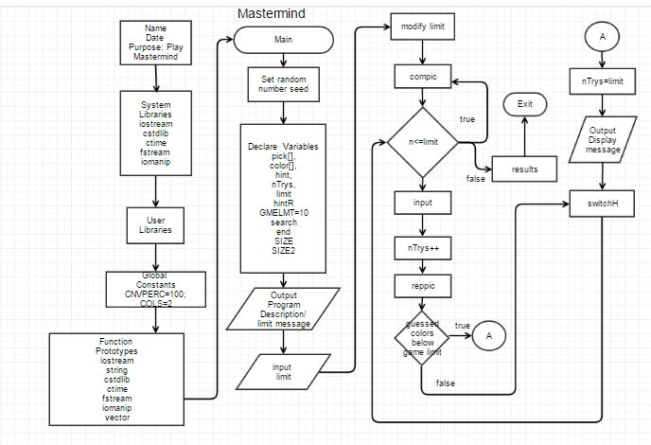Mastermind Main Function

Flowchart of If-Else Decision Statements

(decisions too long to fit in diamonds)

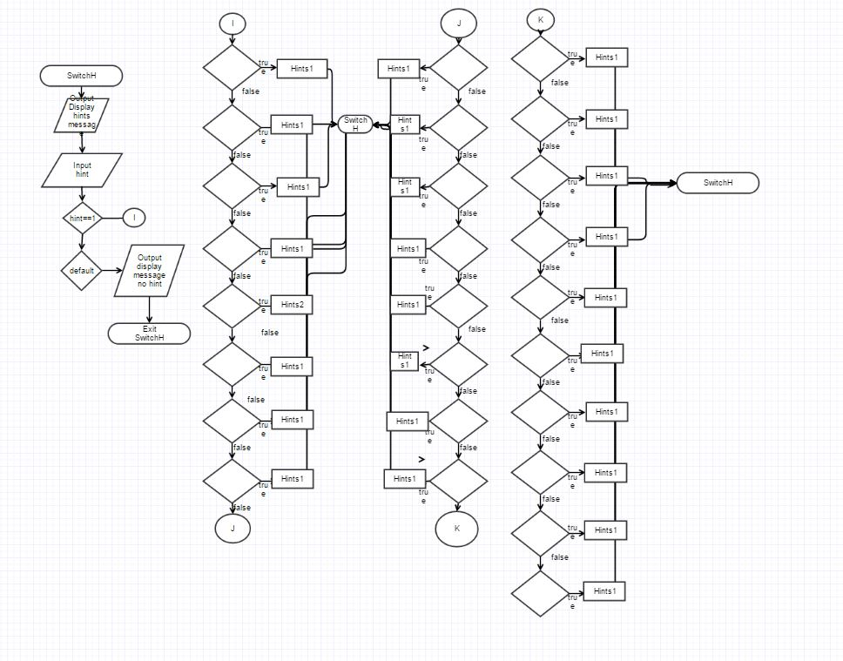

)

Functions named Hints1, Hints2, and Hints 3 (same format as hints1) were placed inside of the switch case function. They all contain long display messages which were originally used many times, over and over. So the Hints functions contain the repeated long display message.

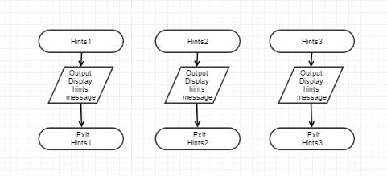

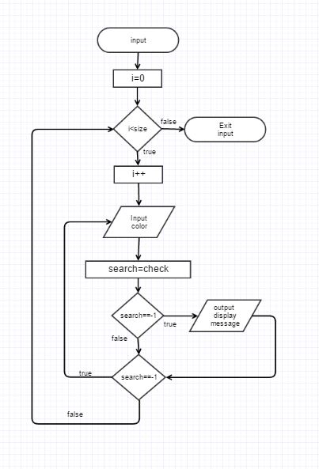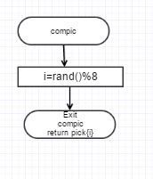

Input Colors Function – Generates the user color array

Computer Random Generated Picks – Fills the picks array with computer choices



Representing the User’s Picks Again- Displaying Table of Choices and how many attempts it has taken them so far.

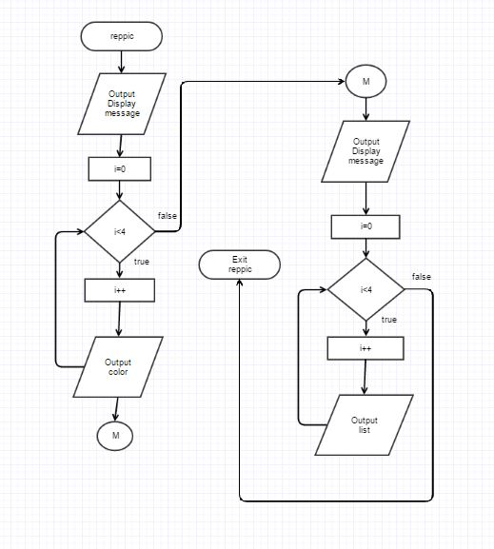

Array to String Conversion Function to Make Table of previous and current choices for the User

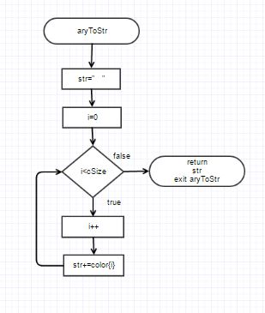

Results Function

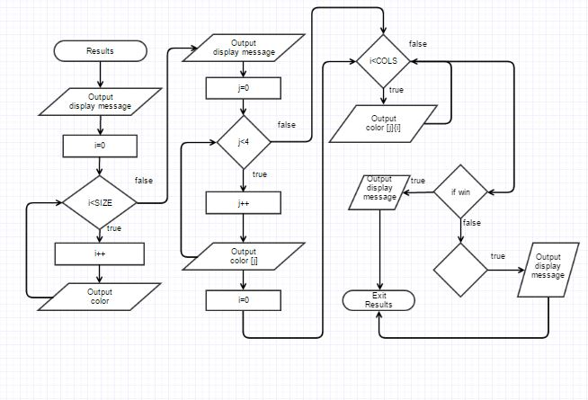

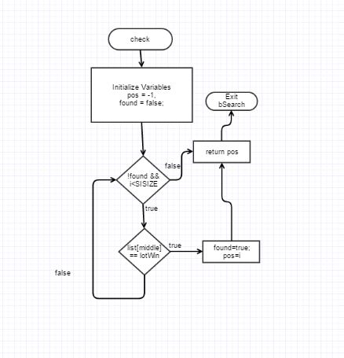 Check Function searches for in valid characters